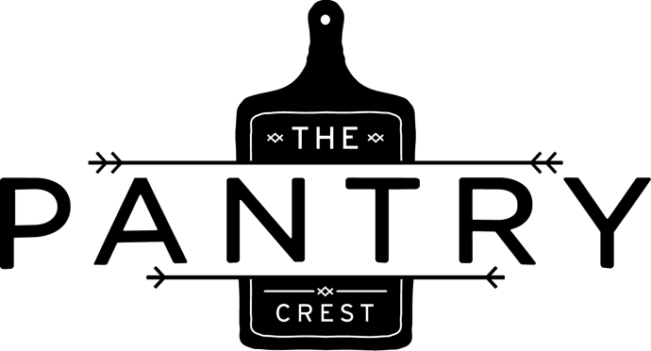
The Bohemian
Becherovka, Clear Creek Apple Brandy, Dolin Rouge, Regans Orange Bitters
The Connection
Citadelle Gin, Galliano, Clear Creek Blackberry Liqueur. Lemon Juice, Stone’s Throw Sausage Fest Hefeweizen
The Modern
Pig’s Nose Blended Scotch, Hayman’s Sloe Gin, House Made Grenadine, Absinthe
The Aviator
Brokers Gin, Luxardo Maraschino Liqueur, Rothman & Winter Crème de Violette, Lemon Juice
El Ponche
Koch el Mezcal infused with Green Tea, Honey Syrup, Lemon Juice, Served Warm
The Concrete
Becherovka, El Guapo Tonic Syrup, Lemon
Bottled Negroni
Brokers Gin, Campari, Cocchi di Torino, Water, Orange Twist, 187 ml , great for sharing!
COCKTAILS

The Bohemian
Becherovka, Clear Creek Apple Brandy, Dolin Rouge, Regans Orange Bitters
The Connection
Citadelle Gin, Galliano, Clear Creek Blackberry Liqueur. Lemon Juice, Stone’s Throw Sausage Fest Hefeweizen
The Modern
Pig’s Nose Blended Scotch, Hayman’s Sloe Gin, House Made Grenadine, Absinthe
The Aviator
Brokers Gin, Luxardo Maraschino Liqueur, Rothman & Winter Crème de Violette, Lemon Juice
El Ponche
Koch el Mezcal infused with Green Tea, Honey Syrup, Lemon Juice, Served Warm
The Concrete
Becherovka, El Guapo Tonic Syrup, Lemon
Bottled Negroni
Brokers Gin, Campari, Cocchi di Torino, Water, Orange Twist, 187 ml , great for sharing!
COCKTAILS

